Project Design Phase-II
Data Flow Diagram & User Stories

Date | 31 Jan 2026
Team ID | LTVIP2026TMIDS37875
Project Name | Heart Disease Analysis
Maximum Marks | 4 Marks

Data Flow Diagrams:

A Data Flow Diagram (DFD) is a graphical representation that illustrates how data moves through a system. It provides a clear and structured view of system requirements by showing:

how data enters the system

how data is processed or transformed

how data is stored

how data leaves the system

Example:

User Stories

User Type
Functional Requirement (Epic)
User Story Number
User Story / Task Acceptance Criteria
Priority / Release

Data Analyst Data Upload USN-1
As a Data Analyst, I can upload Sales and Inventory data to the system
Data successfully uploaded & validated
High / Sprint-1

Data Analyst Dashboard View USN-2
As a Data Analyst, I can view the Sales & Inventory dashboards in Tableau
Visualizations render correctly in Tableau
High / Sprint-1

User Type
Functional Requirement (Epic)
User Story Number
User Story / Task Acceptance Criteria
Priority / Release

Business Manager (End-User)
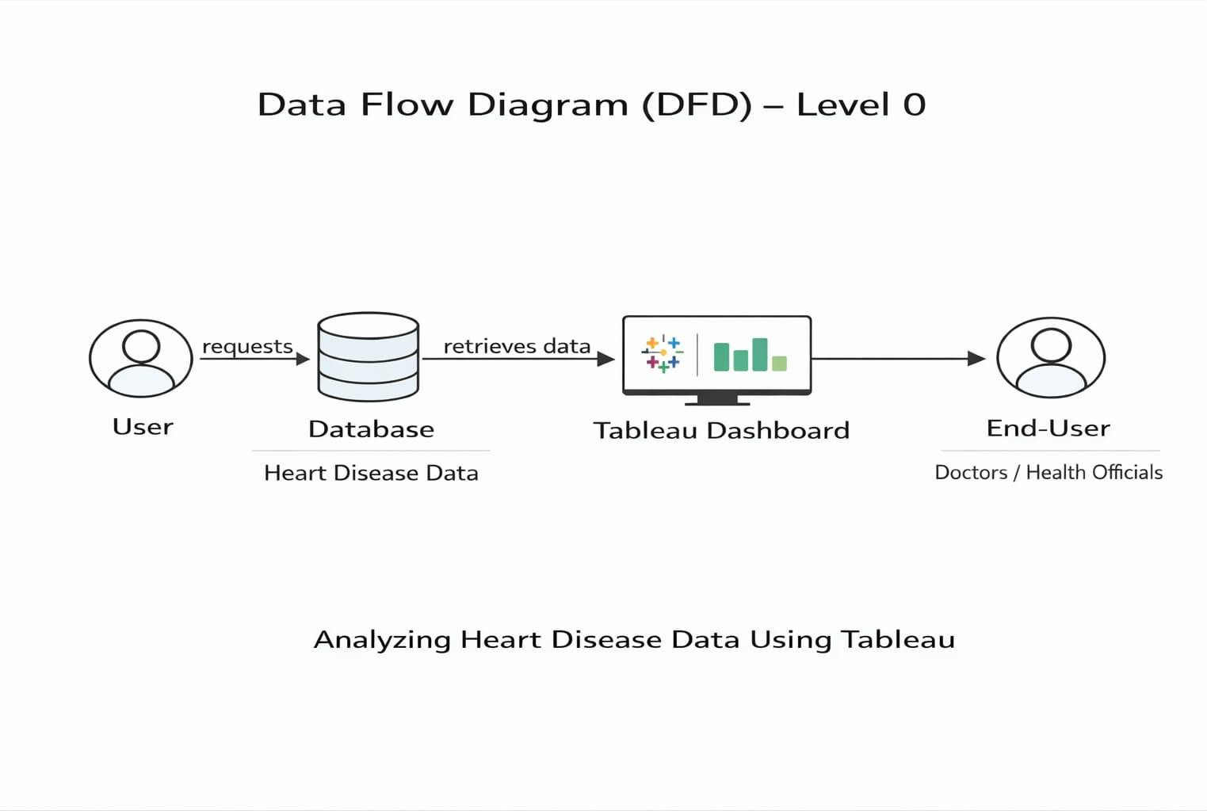
Report Generation USN-3
As a Business Manager, I can generate monthly Sales reports
Report generated accurately & downloadable
Medium / Sprint-2

